

American International University-Bangladesh (AIUB)
Department of Computer Science
Faculty of Science & Technology (FST)

PROJECT TITLE
Semester: Fall 25-26

Group: |  | Section:
SL | Student Name | Student ID
1
2
3
4
5

Table of Contents

1. Project Proposal xx
1.1 Background to the Problem xx
1.2 Selection of Process Model xx
2. Software Requirements Specification (SRS) / PRD xx
2.1 Scopes and Features xx
2.2 User Story Table xx
2.3 Requirements Traceability Matrix xx
2.3.1 Functional Requirements xx
2.3.2 Non-Functional Requirements xx
3. Software Design xx
3.1 System Deisgn xx
3.2 UI Deisgn using Figma xx
4. Git Workflow xx
5. Software Testing xx
6. Conclusion xx

1. PROJECT PROPOSAL

  - Background to the Problem

  - Selection of Process Model
- Select a suitable Process Model for your project. Then, explain the process model with proper visualization. After that, you need to explain that ‘why did you choose this model’.

2. SOFTWARE REQUIREMENTS SPECIFICATIONS (SRS) / PRODUCT REQUIREMENTS DOCUMENT (PRD)

2.1 Scopes and Features

2.2 User Story Table

2.3 Requirements Traceability Matrix

2.3.1 Functional Requirements

2.3.2 Non-Functional Requirements

3. SOFTWARE DESIGN
3.1 System Design: Draw the system design for your project using Draw.io or LucidChart.
- Prepare a Use Case Diagram by first defining all users (actors) and their roles. Show each actor’s interactions with the system through use cases inside a system boundary. Include relationships like include or extend where needed.
- Prepare a Class Diagram by identifying the main classes from your project. Add attributes and operations for each class, and show associations, generalizations, aggregations, or compositions between them.
- Prepare an Activity Diagram that visually represents the workflow of a system or process.

UI / Wireframe Design using Figma
- Build the wireframes directly from your SRS. Each functional requirement defined in the SRS should have a corresponding screen or component in the UI.
- Use the Trello user board (or equivalent task board) as a reference to decide which features and user flows need to be represented in the prototype.
- Create clickable wireframes that connect the main screens together, showing how a user will navigate through the system.
- Ensure the wireframe matches the actors, roles and functionalities described in the SRS and system design diagrams.
- Export the prototype and include screenshots or a link to your design as part of the report submission.

4. GIT WORKFLOW
- Create a central repository for the project on GitHub and set the master (or main) branch as the primary branch for integration.
- Each member should clone the repository and create their own feature branches for assigned tasks. Work on new features or fixes within these branches.
- Add files, stage them and commit changes with clear messages that describe the purpose of each update.
- Push commits from the feature branches to the remote repository so other members can see progress.
- Use pull to fetch and integrate changes from the remote repository into local copies, ensuring everyone stays updated.
- Merge feature branches into the master/main branch only after the work is tested and reviewed, resolving any conflicts that occur.
- Show evidence of collaboration by maintaining a clear commit history (using logs) with multiple commits, merges and contributions from all group members.
- Keep the repository organized with a clean history that tracks the project workflow from initialization to completion.

5. SOFTWARE TESTING
- Identify some testing methods that you want to use in the testing phase later for your project.
- Prepare 3 test cases using a manual test case template which template taught you in the class. Suppose if you have total 4 members, then the total test cases will be 12.

6. CONCLUSION
- Write a conclusion within 180 to 200 words.

Instructions:
- Minimum of 3 members and Maximum of 5 members per group.
- Font: Times New Roman ; Size: 12; Justify the para [Ctrl + J].
- Delete the highlighted part after completing this project report.
- The completed report should be within the range of 40 to 50 pages.

- Submission: Bring a hard copy of this report [per group] on the project evaluation day. Also, you will need to upload the soft copy later.

## Background of the Problem

Hospitals are complex organizations where many departments work together to provide proper patient care. Doctors, nurses, receptionists, laboratory staff, and patients all depend on accurate information and smooth communication. In many hospitals, especially small and medium-sized ones, patient records, appointment schedules, admission details, and test reports are still handled manually or through separate systems. This traditional way of management creates several problems such as data duplication, loss of records, delays in service, and human errors. Managing large amounts of patient data using paper files also makes the process slow and inefficient.

Patients often face difficulties in booking appointments, getting admitted, or collecting test reports on time. Doctors may not have quick access to patient history, and nurses may find it hard to track the current condition of admitted patients. Similarly, receptionists and laboratory staff need constant coordination with other departments, which becomes difficult without a centralized system. These issues not only waste time but also affect the quality of healthcare services.

To overcome these problems, a computerized Hospital Management System is required. This system brings all hospital activities under one platform where each user can access the system based on their role. Patients can book doctor appointments and view test reports, doctors can manage patient visits and assign tests, nurses can update patient conditions, receptionists can handle admissions and doctor information, and phlebotomists can submit test reports. Overall, the system helps improve efficiency, accuracy, data security, and communication within the hospital.

---

## Selection of the Process Model (Scrum Model)

For the development of this Hospital Management System, the **Scrum model**, which is an Agile software development approach, has been selected. Scrum is suitable for this project because it allows the system to be developed in small and manageable parts instead of building everything at once. The project is divided into short development cycles called sprints, where each sprint focuses on a specific set of features such as user authentication, appointment booking, admission management, or test reporting.

One of the main advantages of the Scrum model is flexibility. Requirements can be reviewed and improved after each sprint based on feedback from team members or instructors. This is especially helpful for an academic project, where understanding of requirements may improve during development. Scrum also encourages regular communication through meetings such as sprint planning, daily stand-ups, sprint review, and sprint retrospective, which helps the team stay organized and focused.

Another reason for choosing Scrum is that it supports teamwork and continuous improvement. Each team member has clear responsibilities, and progress can be monitored easily after every sprint. Testing is also done regularly, which helps identify errors early and improve system quality. Due to its iterative nature, ease of management, and adaptability, the Scrum model is an appropriate and effective choice for developing the Hospital Management System in this software engineering course.

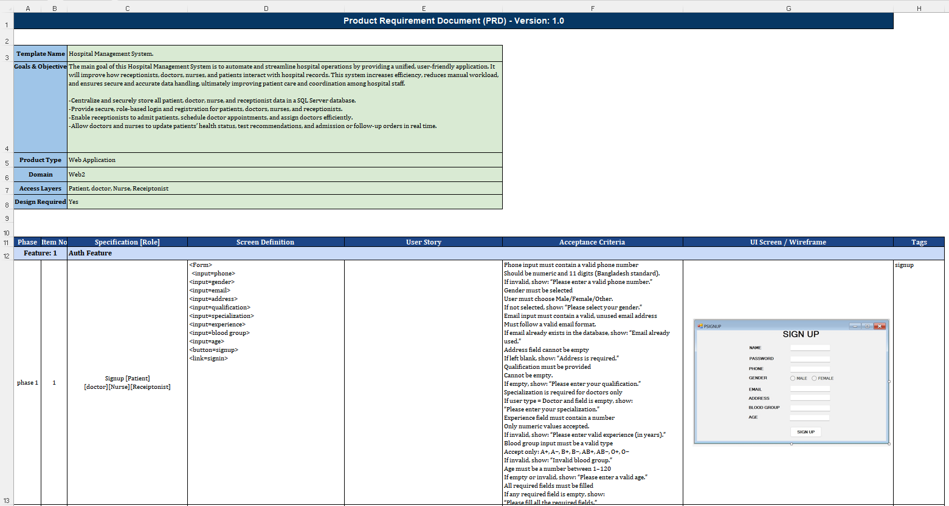

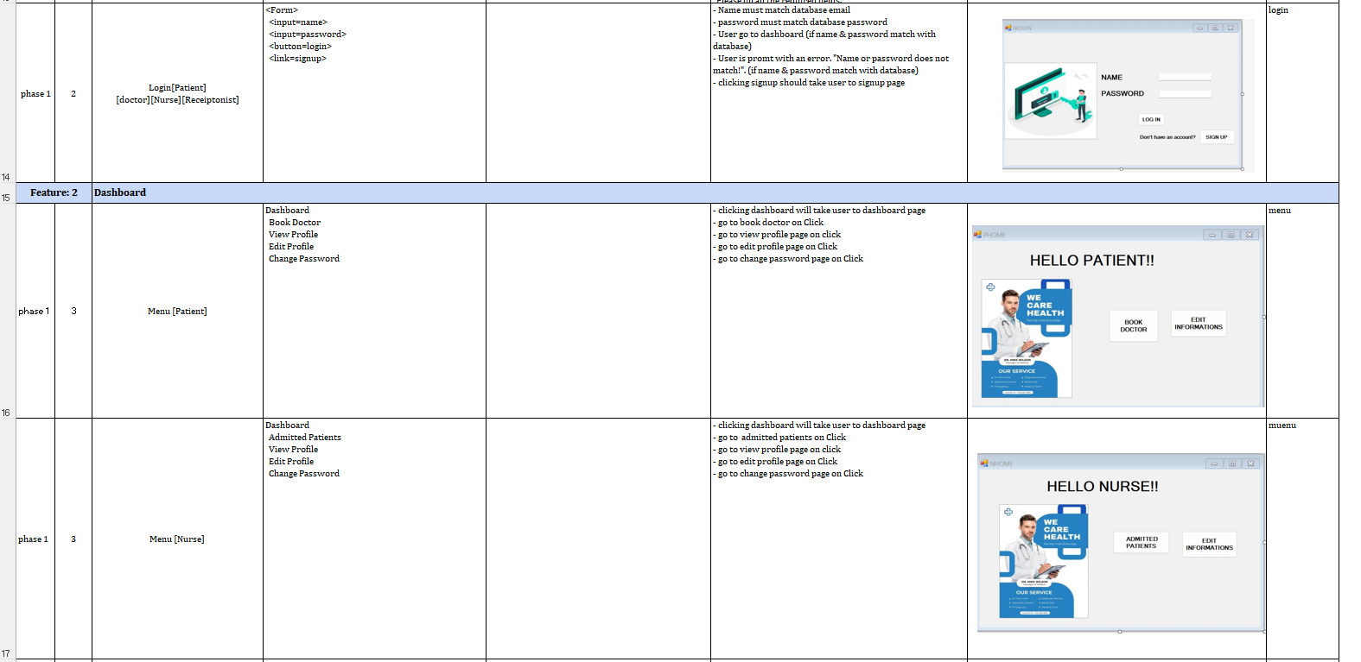
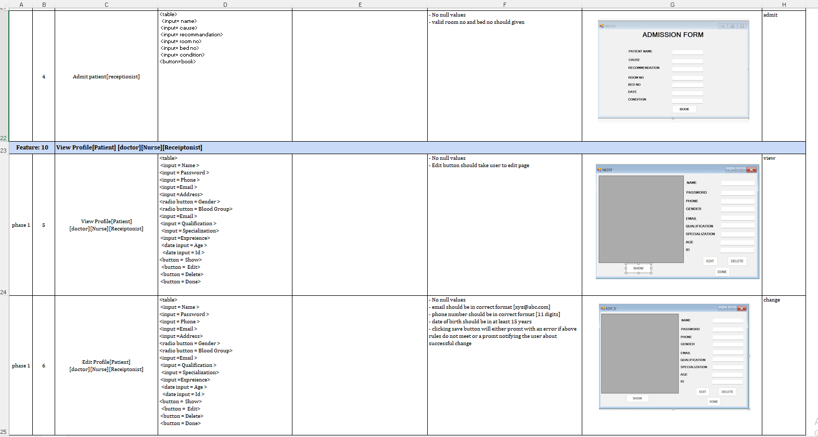
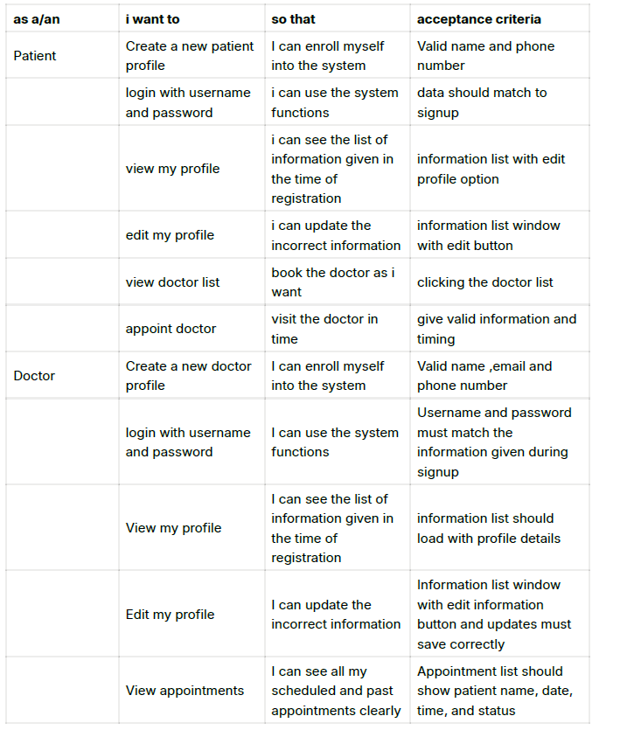

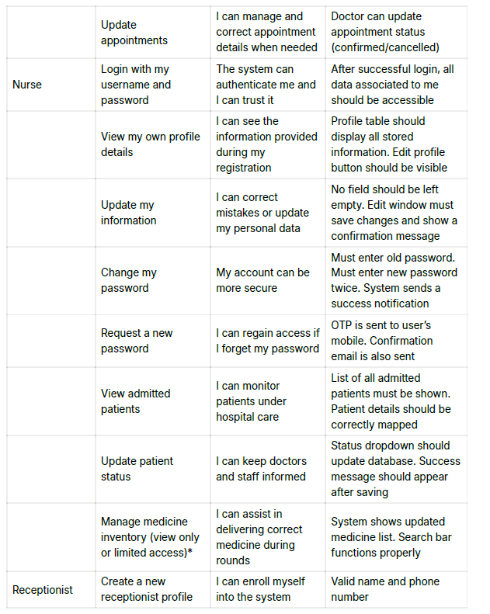

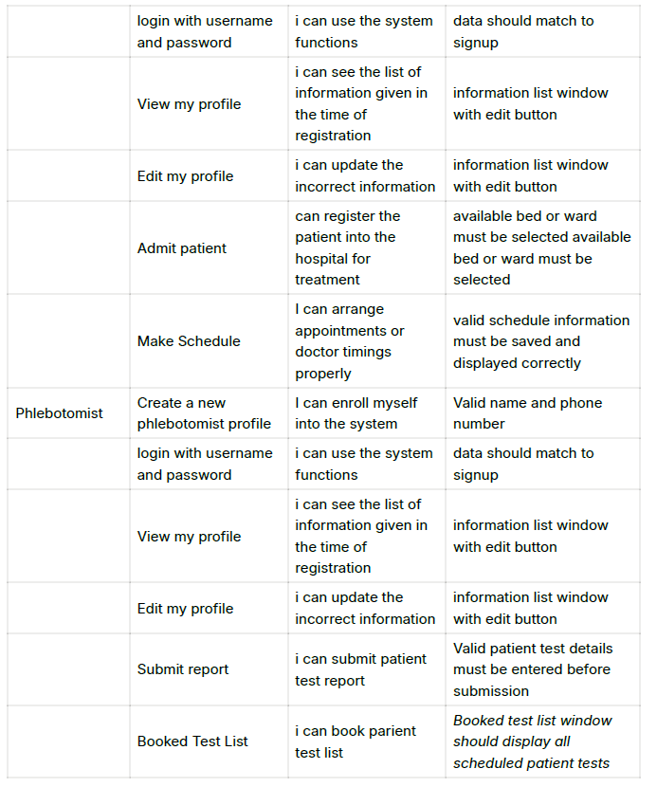

Requirements Traceability Matrix (RTM)
The Requirements Traceability Matrix (RTM) is used to map system requirements with their corresponding system modules and test cases. It ensures that every requirement defined for the Hospital Management System is properly designed, implemented, and tested. RTM helps in tracking requirements throughout the software development life cycle and confirms that no requirement is left unaddressed.
Functional Requirements Traceability Matrix

ID
Req.  ID | Requirement Description | User Type | System Module |  | Test Case  ID
FR-01 | User can sign up into the system | All Users | Authentication  Module |  | TC-01
FR-02 | User can log in and log out | All Users | Authentication  Module |  | TC-02
FR-03 | User can update personal information | All Users | Profile Management |  | TC-03
FR-04 | Patient can view doctor list and timings | Patient | Doctor Information Module |  | TC-04
FR-05 | Patient can book doctor appointment | Patient | Appointment Management |  | TC-05
FR-06 | Patient can view test reports | Patient | Report Management |  | TC-06
FR-07 | Receptionist can add/update doctor information | Receptionist | Doctor Management |  | TC-07
FR-08 | Receptionist can admit patients | Receptionist | Admission Management |  | TC-08
FR-09 | Doctor can view patient booking list | Doctor | Appointment Management |  | TC-09
FR-10 | Doctor can update patient condition | Doctor | Patient Record  Module |  | TC-10
FR-11 | Doctor can assign medical tests | Doctor | Test Assignment Module |  | TC-11
FR-12 | Nurse can view admitted patient list | Nurse | Admission Management |  | TC-12
FR-13 | Nurse can update patient condition | Nurse | Patient Record  Module |  | TC-13
FR-14 | Phlebotomist can view assigned test list | Phlebotomist | Test Management |  | TC-14
FR-15 | Phlebotomist can submit test reports | Phlebotomist | Report Management |  | TC-15

Non-Functional Requirements Traceability Matrix

Req.  ID | Non-Functional  Requirement | Description | Validation Method
NFR-01 | Usability | System should be easy to use for all users | User Testing
NFR-02 | Performance | System should respond quickly to user actions | Performance Testing
NFR-03 | Security | User data must be protected using authentication | Security Testing
NFR-04 | Reliability | System should work without failure during use | System Testing
NFR-05 | Availability | System should be accessible during hospital hours | Operational Testing
NFR-06 | Scalability | System should support future feature expansion | Design Review
NFR-07 | Data Integrity | Stored data should remain accurate and consistent | Database Testing

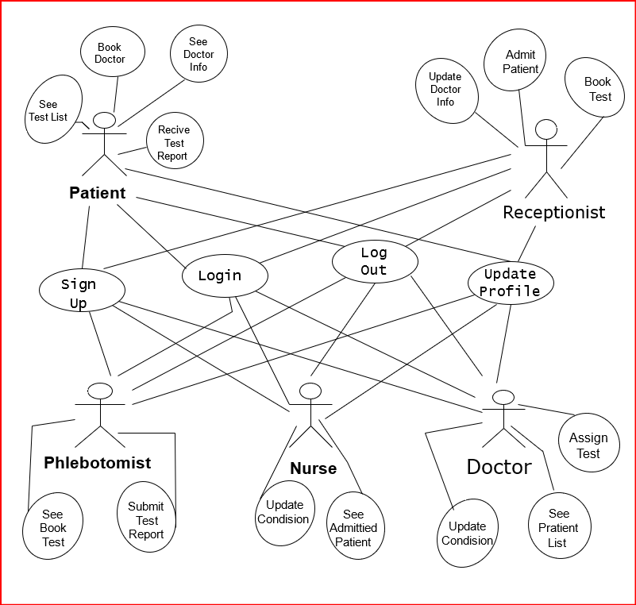

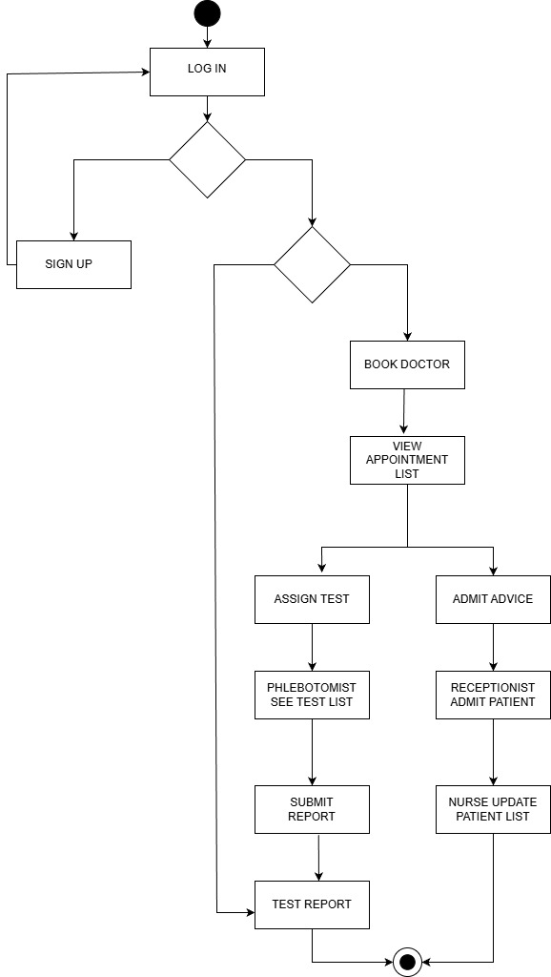

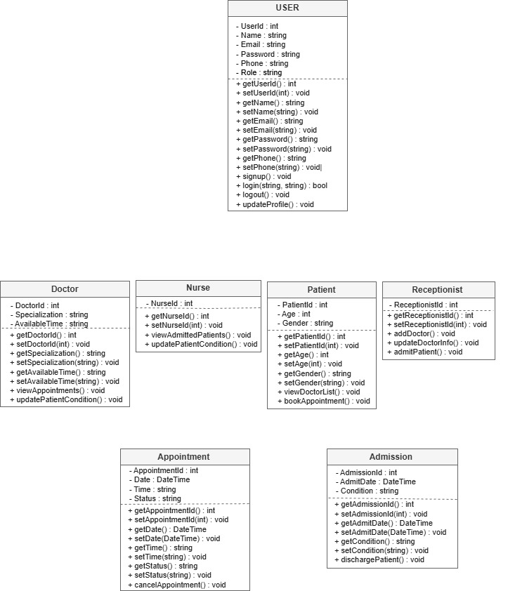

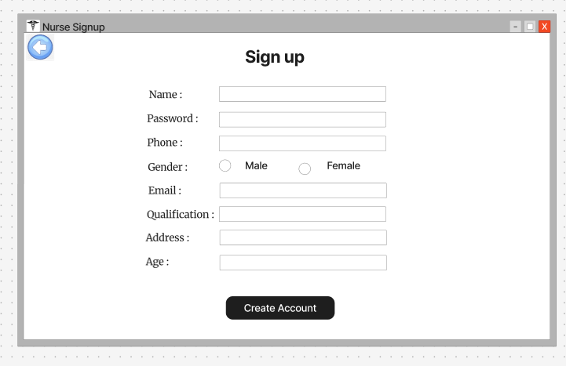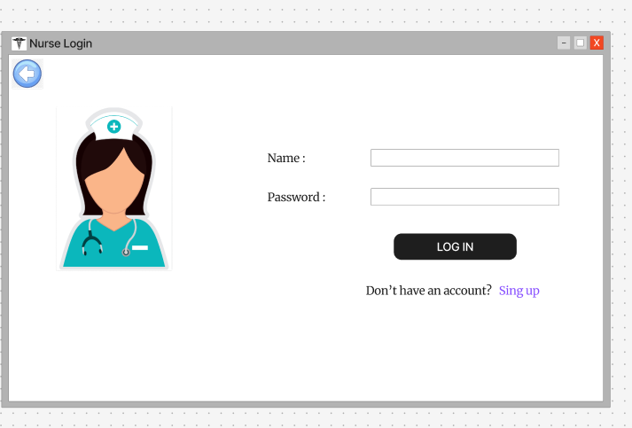
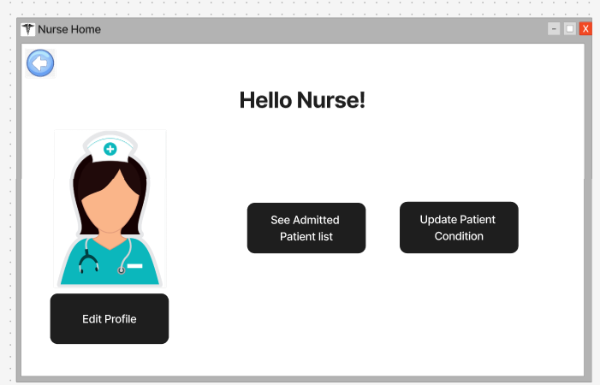

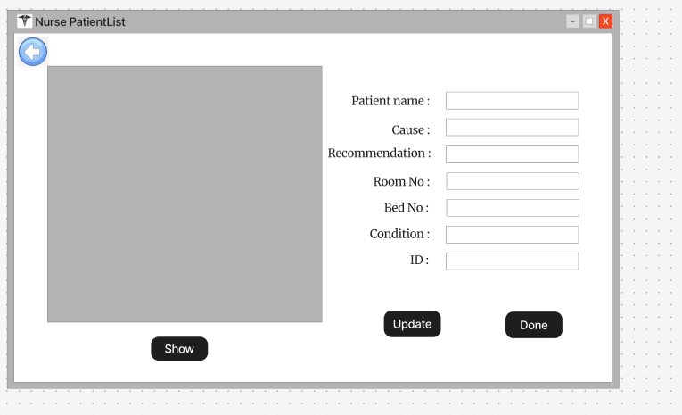

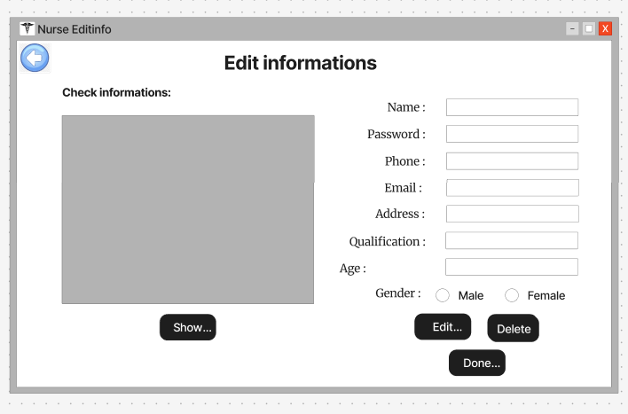
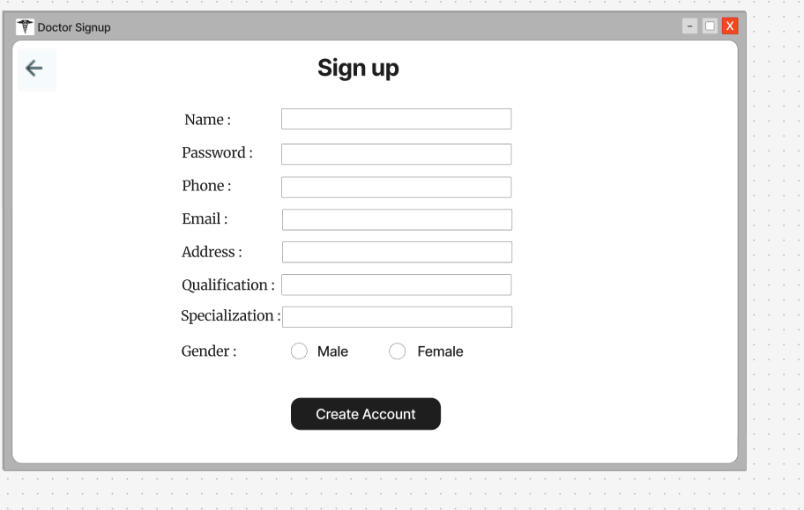
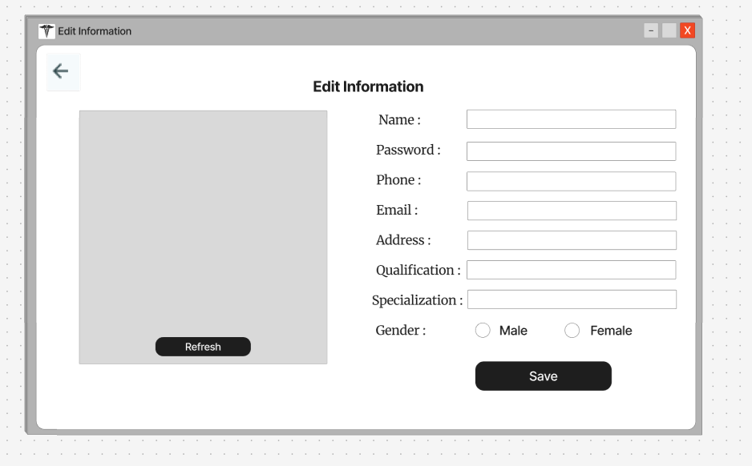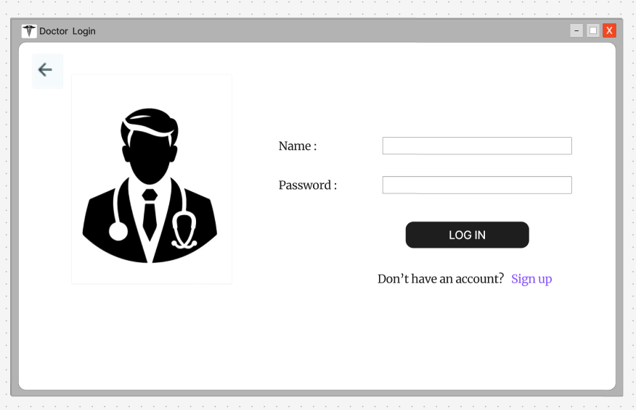

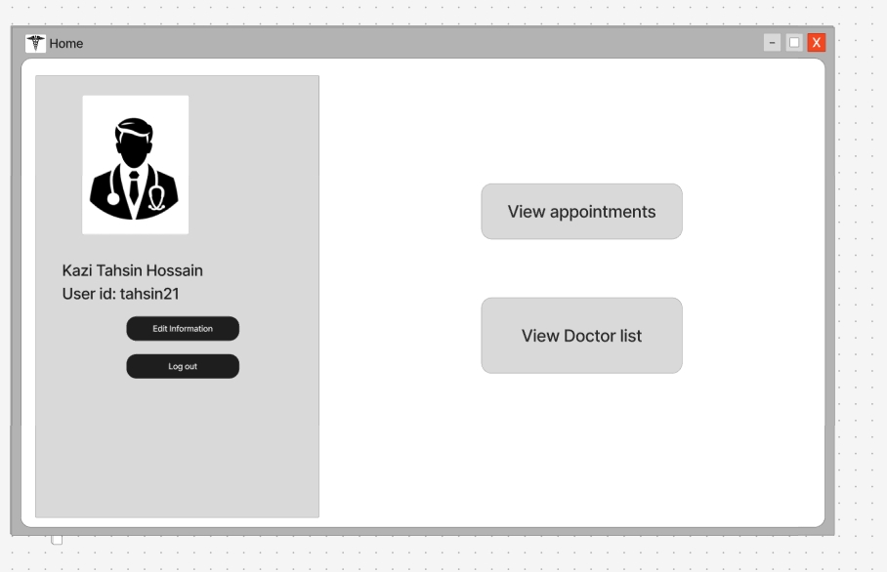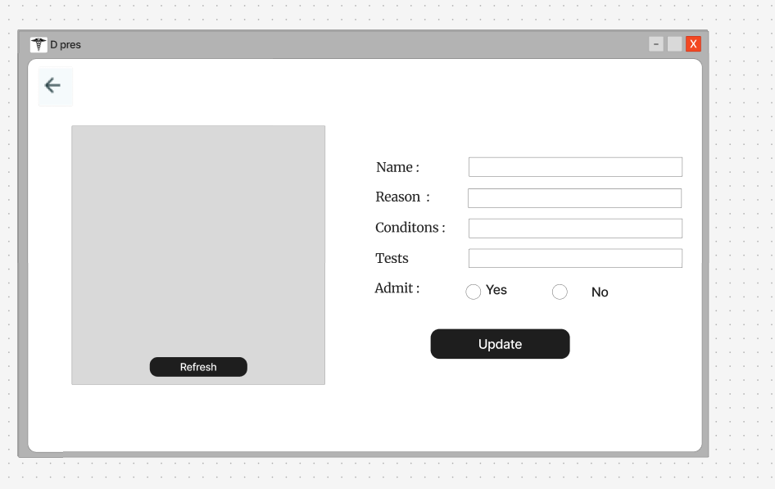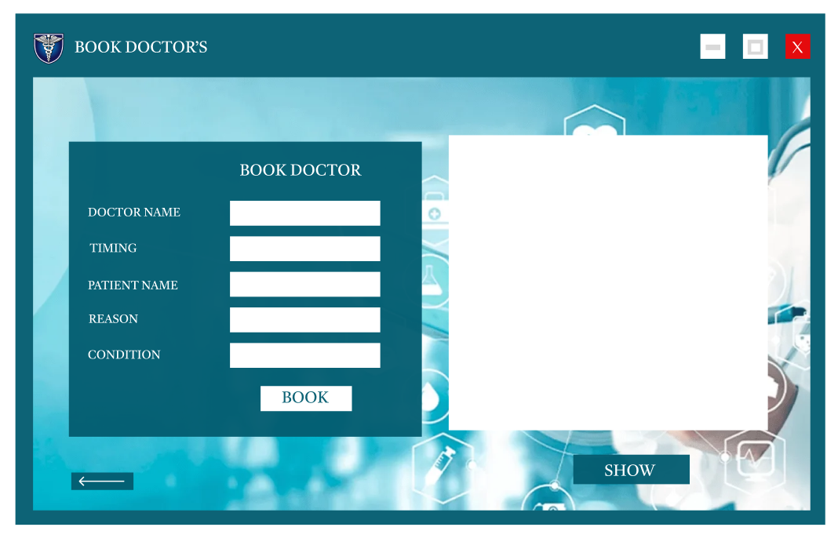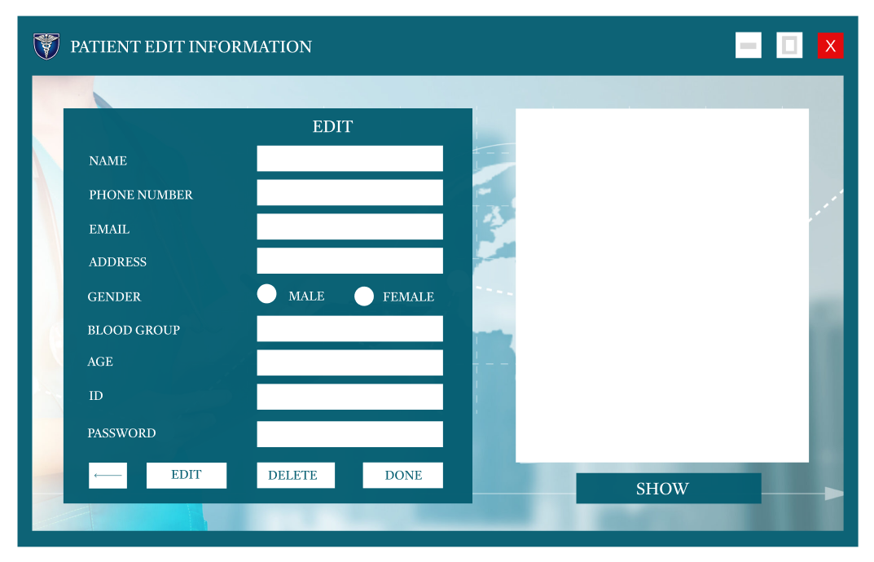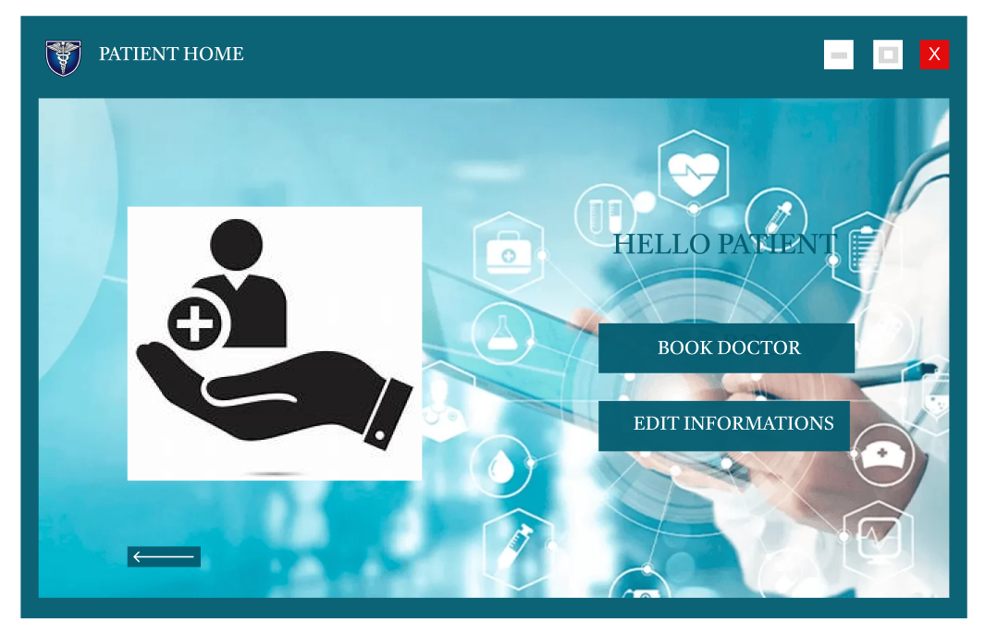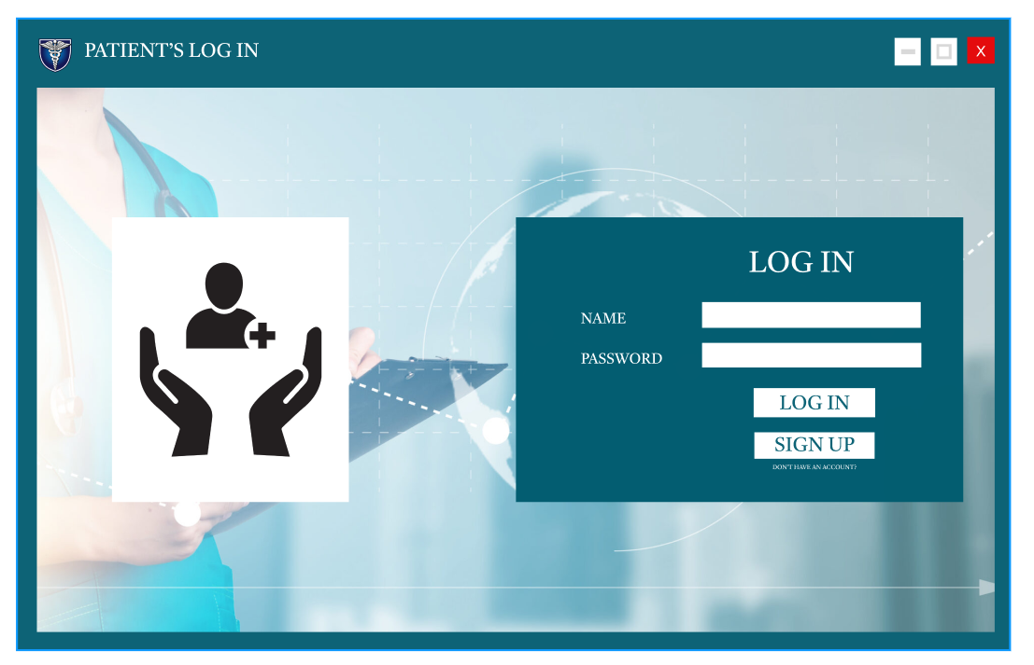
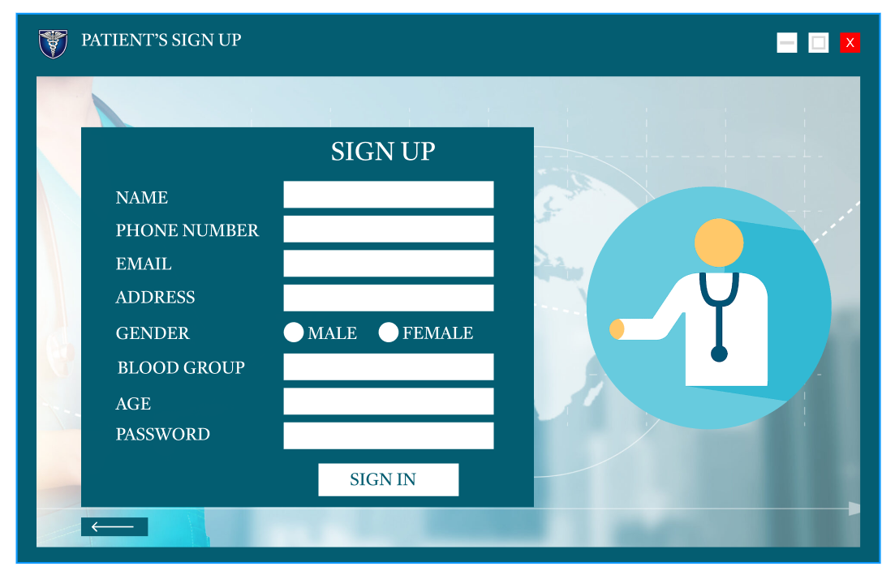
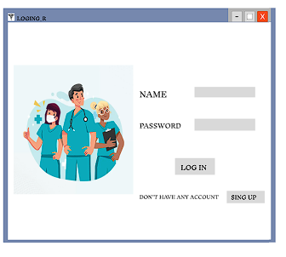
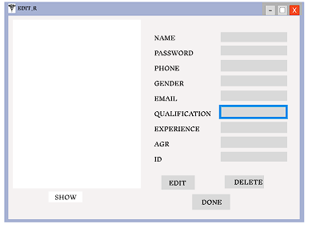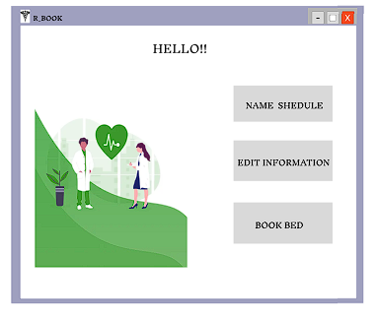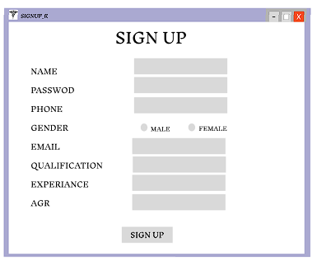

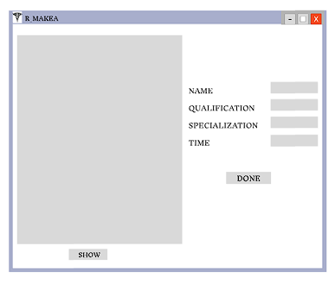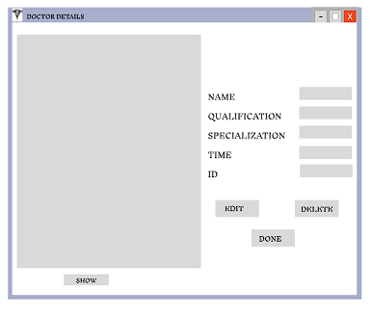

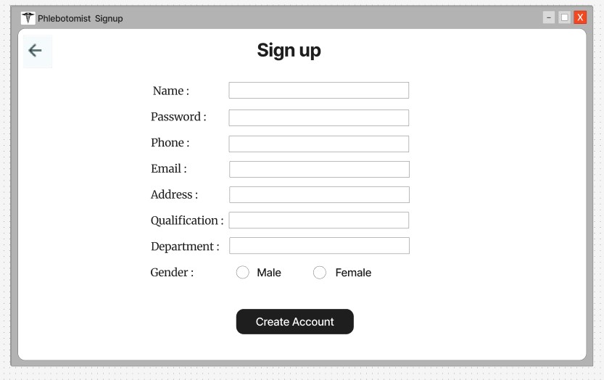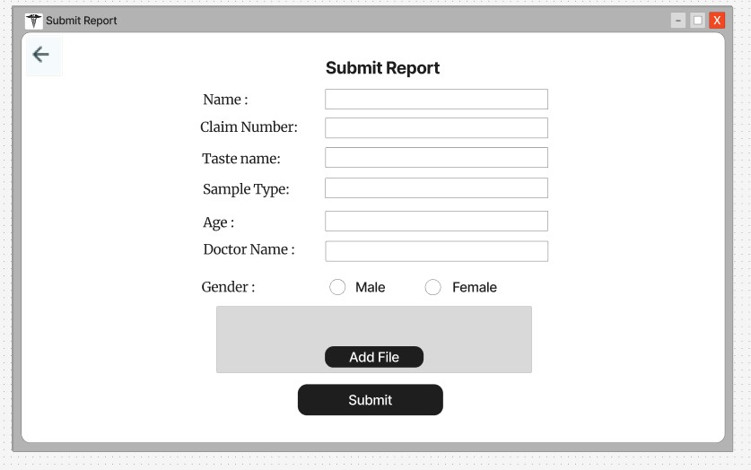
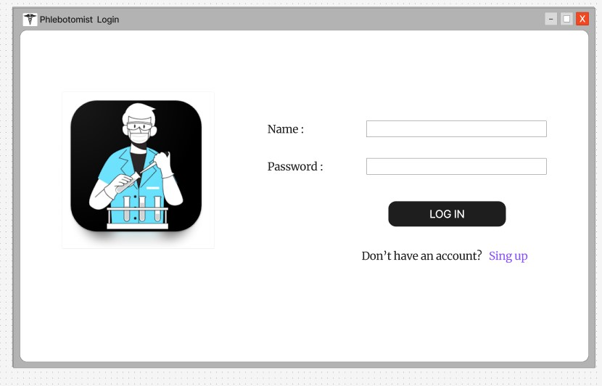
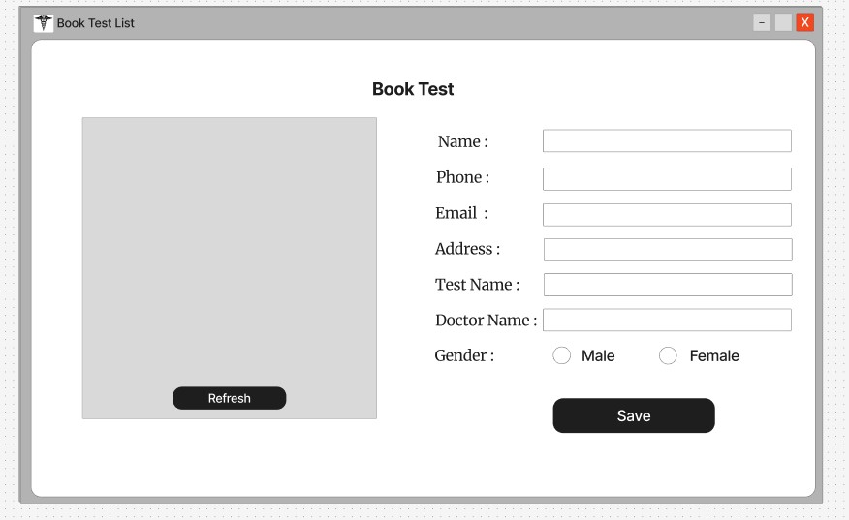
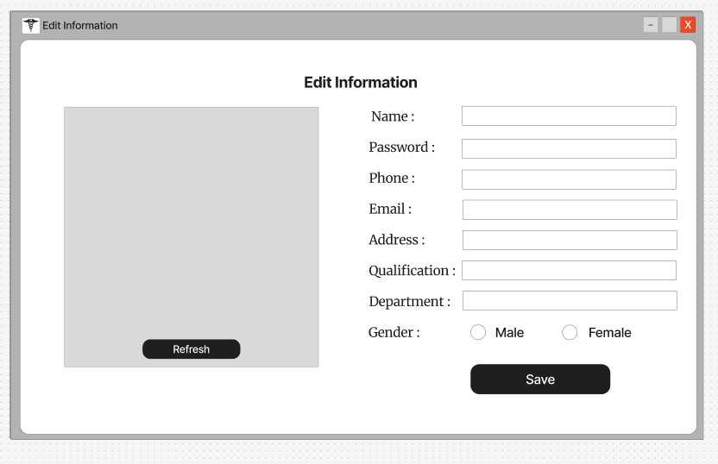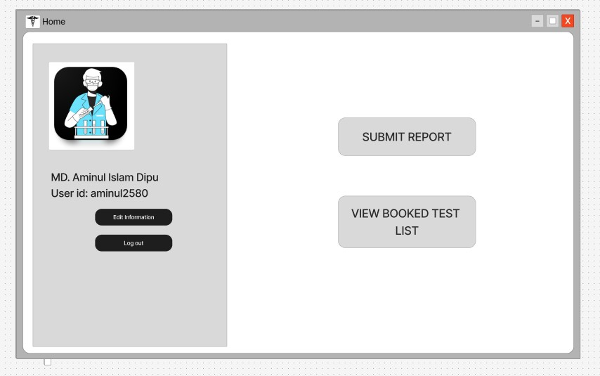

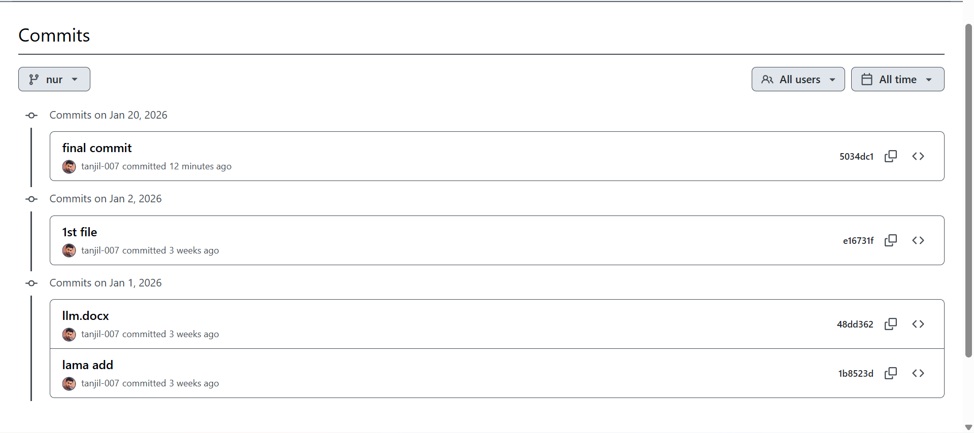

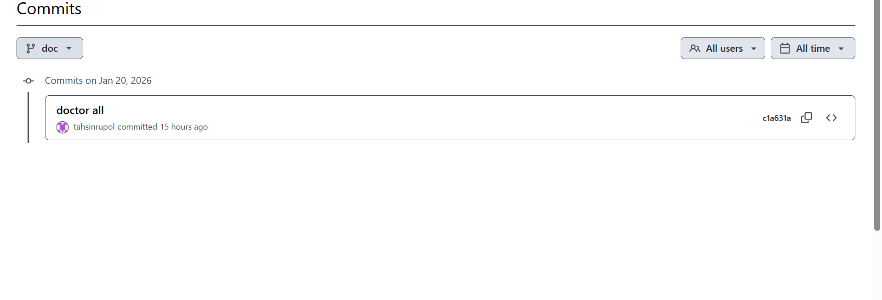

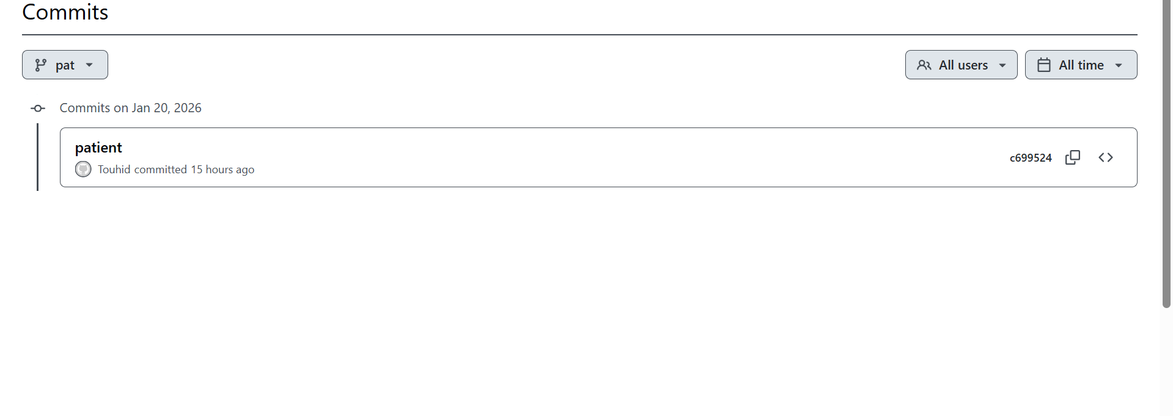

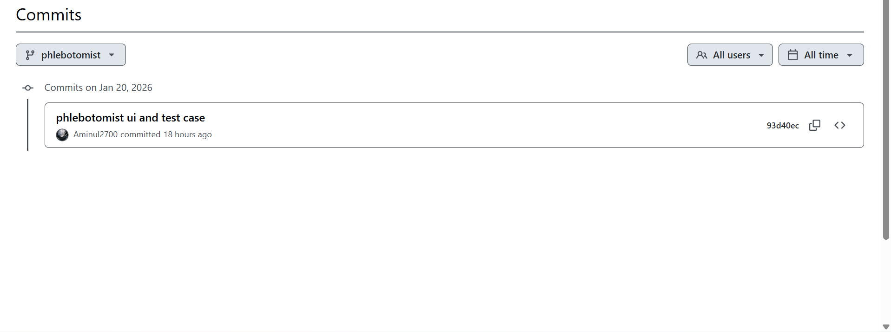

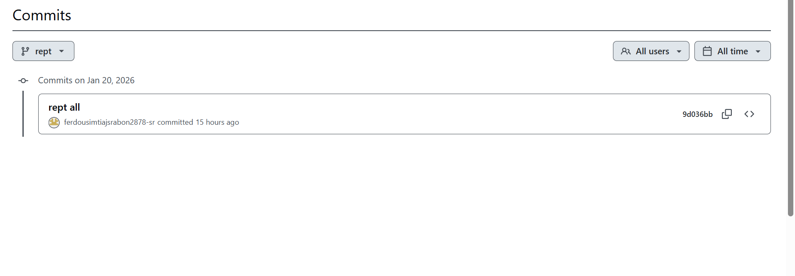

Project Name: Hospital management system |  | Test Designed by: Ferdous Imtiaj Srabon
Test case Id:TC_1 |  | Test Designed Date: 1.5.2026
Test priority (easy, medium, high): medium |  | Test Executed by:Name
Module name:Edit Session |  | Test Execution Date:19.01.26
Test Title:Edit information
Description:Test the webside edit page
Precondition:Sucessful login
Dependencies:
Test Step | Test Data | Expected result | Actual result | Status(fail/pass)
1.Go to the site  2.Sucessful login  3.Click the Edit information button  4.Edit as required  5.Click Edit button | Name:rrre55  Password:555 | The user should edit and delete application | As expected | pass

Project Name: Hospital management system |  | Test Designed by: Md. Aminul islam Dipu
Test case Id:TC_2 |  | Test Designed Date: 1.5.2026
Test priority (easy, medium, high): medium |  | Test Executed by:
Module name:Home page |  | Test Execution Date:
Test Title:Verify home page Navigation Buttons Functionality
Description:Verify the home page
Precondition:user has access to the system
Dependencies: Schedule management module ,information edit and brd booking module
Test Step | Test Data | Expected result | Actual result | Status(fail/pass)
1.Launch the application  2. Welcome message  3. Edit schedule  4.Edit information  5.Book bed | Hello | Home page loads successfully  Welcome message display  Redirects to edit information page  Redirects to Bed Booking page | As Expected all the button | pass

Project Name: Hospital management system |  | Test Designed by: Ferdous Imtiaj Srabon
Test case Id: |  | Test Designed Date: 1.5.2026
Test priority (easy, medium, high): medium |  | Test Executed by:
Module name: Sign Up |  | Test Execution Date:
Test Title:verify user sign-up with valid details
Description: This test case verifies that a new user can successfully register by providing valid information such as name, password, phone number, gender, email, qualification, experience, and age.

Precondition: User is on the Sign Up page
Dependencies: User Authentication Module
Test Step | Test Data | Expected result | Actual result | Status(fail/pass)
1Open Sign Up page  2. Enter Name  3.Enter Password  4.Enter Phone Number  5. Select Gender  6. Enter Email  7.Enter Qualification  8. Enter Experience  9. Enter Age  10. Click Sign Up button | Name:eeee  Password:638  Phone:393939  Gender:male  Email:sss@.com  Qualification:BSc  Experience:phd  Age:55 | All the information successfully valid and then accept | As expected | pass

Project Name: Hospital management system |  | Test Designed by: Ferdous Imtiaj Srabon
Test case Id: |  | Test Designed Date: 1.5.2026
Test priority (easy, medium, high): medium |  | Test Executed by:
Module name: Doctor List Management |  | Test Execution Date:
Test Title: Verify system behavior when editing doctor details with invalid or missing data
Description: This test case verifies that the system does not allow editing or saving doctor information when required fields (name, qualification, time, ID) are missing or invalid, and proper error messages are shown.

Precondition: Doctor list page is opened
Dependencies: Doctor Management Module
Test Step | Test Data | Expected result | Actual result | Status(fail/pass)
- Open Doctor List page  2. Click Edit button  3. Clear Doctor Name field  4. Enter invalid Qualification  5. Leave Time field empty  6. Enter invalid Doctor ID  7.Click Done  8. Click Delete without confirmation | Doctor ID: D101  ###  s@ | Doctor list displayed | Error | Fail

Project Name: Hospital management system |  | Test Designed by: Touhid A Akbar
Test case Id:TC_1 |  | Test Designed Date: 1.19.2026
Test priority (easy, medium, high): medium |  | Test Executed by:
Module name: Patient signup functionality |  | Test Execution Date: 1.19.2026
Test Title: Verify patient signup
Description: Test the patient module to verify that a patient can sign up
Precondition: The patient must be registered in the system and the application must be running properly.
Dependencies: Database connection, Doctor module, Patient module
Test Step | Test Data | Expected result | Actual result | Status(fail/pass)
1. Open the application  2. Click Sign Up  3. Enter patient details  4. Click SIGNIN | Name: Touhid  Phone: 017xxxxxxx  Email: touhid@gmail.com  Address: Dhamrai  Gender: Male  Blood Group: O+  Age:24  Password: 12345 | Patient account should be created successfully | As expected | Pass

Project Name: Hospital management system |  | Test Designed by: Touhid A Akbar
Test case Id:TC_2 |  | Test Designed Date: 1.19.2026
Test priority (easy, medium, high): medium |  | Test Executed by:
Module name: Booking |  | Test Execution Date:
Test Title: Doctor booking
Description: Test the patient module to verify that a patient can book a doctor
Precondition: The patient must be registered in the system and the application must be running properly.
Dependencies: Database connection, Doctor module, Patient module
Test Step | Test Data | Expected result | Actual result | Status(fail/pass)
1. Click Book Doctor  2. Select doctor name  3. Select time  4. Enter patient name  5. Enter reason  6. Enter condition  7click BOOK | Doctor: Dr. Rahman  Time: 10 AM  Patient name: TOUHID  Reason:advice  Condition:Bad | Booking form should open successfully |  | PASS
  As expected

Project Name: Hospital management system |  | Test Designed by: Touhid A Akbar
Test case Id:TC-3 |  | Test Designed Date: 1.19.2026
Test priority (easy, medium, high): medium |  | Test Executed by:
Module name: Booking |  | Test Execution Date: 1.19.2026
Test Title: Doctor booking
Description: Book a doctor
Precondition: The patient must be registered in the system and the application must be running properly.
Dependencies: Database connection, Doctor module, Patient module
Test Step | Test Data | Expected result | Actual result | Status(fail/pass)
1. Enter booking reason  2. Click Book | Reason: Fever |  | Booking failed | Fail
  Appointment should be booked successfully

Project Name: Hospital management system |  | Test Designed by: Touhid A Akbar
Test case Id:TC-4 |  | Test Designed Date: 1.5.2026
Test priority (easy, medium, high): medium |  | Test Executed by:
Module name: Edit Information |  | Test Execution Date:
Test Title: Edit information functionality
Description: Test the patient module to verify that a patient can edit personal information successfully.
Precondition: The patient must be registered in the system and the application must be running properly.
Dependencies: Database connection, Doctor module, Patient module
Test Step | Test Data | Expected result | Actual result | Status(fail/pass)
1. Click Edit Information  2. Update phone number  3. Click DONE | Phone: 01867890901 |  | As expected | Pass
  Patient information should be updated

Project Name: Hospital management system |  | Test Designed by: Kazi Tahsin Hossain
Test case Id:TC-91 |  | Test Designed Date: 1.5.2026
Test priority (easy, medium, high): medium |  | Test Executed by:
Module name: Edit Information |  | Test Execution Date:
Test Title: Edit information functionality
Description: Test the doctor module to verify that a doctor can edit doctor information successfully.
Precondition: The doctor must be registered in the system and the application must be running properly.
Dependencies: Database connection, Doctor module.
Test Step | Test Data | Expected result | Actual result | Status(fail/pass)
1. Click Edit Information  2. Update email  3. Click DONE | Email: tahsin@gmail.com |  | As expected | Pass
  Doctor information should be updated

Project Name: Hospital management system |  | Test Designed by: Kazi Tahsin hossain
Test case Id:TC_90 |  | Test Designed Date: 1.19.2026
Test priority (easy, medium, high): medium |  | Test Executed by: rupol
Module name: doctor signup information functionality |  | Test Execution Date: 1.19.2026
Test Title: Verify doctor signup page
Description: Test the doctor module to verify that a doctor can sign up
Precondition: The doctor must be registered in the system and the application must be running properly.
Dependencies: Database connection, Doctor module.
Test Step | Test Data | Expected result | Actual result | Status(fail/pass)
1. Open the application  2. Click Sign Up  3. Enter doctor details  4. Click SIGNIN | Name: tahsin  Phone: 017xxxxxxx  Email: tah@gmail.com  Address: dhaka  Gender: Male  Blood Group: O+  Age:20  Password: 12345 | doctor signup should be created successfully | As expected | Pass

Project Name: Hospital management system |  | Test Designed by: Kazi Tahsin Hossain
Test case Id:TC92 |  | Test Designed Date: 1.19.2026
Test priority (easy, medium, high): medium |  | Test Executed by:Tester
Module name: Doctor Homepage |  | Test Execution Date: 1.19.26
Test Title: Verify Doctor Home page Navigation
Description: To verify that doctor can view appointments and edit info from homepage.
Precondition: Doctor must be registered and successful login.
Dependencies: login module, database connection
Test Step | Test Data | Expected result | Actual result | Status(fail/pass)
1.Verify welcome text.  2.click on “view appointment” button  3.click on “edit information ”buttn | 1.welcome text | 1.appointment list should open  2.edit information page should open | As expected | Pass

Project Name: Hospital management system |  | Test Designed by: Kazi Tahsin Hosssain
Test case Id:TC93 |  | Test Designed Date: 1.19.2026
Test priority (easy, medium, high): medium |  | Test Executed by:Tester
Module name:Doctor Module |  | Test Execution Date:1.19.26
Test Title:Verify doctor can search and update patient information.
Description:To verify that doctor can search patient details and update condition
Precondition: successful login, patient record must exist in database
Dependencies: appointment module, patient modeule, database connectivity
Test Step | Test Data | Expected result | Actual result | Status(fail/pass)
1.enter patient id  2.click search button  3.update condition field  4.click update button  5.click done button | 1.valid patient id  2.update condition text  3.update data | 1.patient details should load.  2.patient data should be displayed.  3.condition should update  4.database should save the data. | The condition update is not working . | Failed .

Project Name: Hospital management system |  | Test Designed by: Md. Aminul Islam Dipu
Test case Id: Test Case 1 |  | Test Designed Date: 19.01.2026
Test priority (easy, medium, high): medium |  | Test Executed by: Md. Aminul Islam Dipu
Module name: Phlebotomist signup functionality |  | Test Execution Date: 19.01.2026
Test Title: Verify phlebotomist signup
Description: Test the phlebotomist module to verify that a phlebotomist can sign up.
Precondition: The phlebotomist must be registered in the system and the application must be running properly.
Dependencies: Database connection, Doctor module, Patient module.
Test Step | Test Data | Expected result | Actual result | Status(fail/pass)
1. Open the application 2. Click Sign Up  - Enter phlebotomist details  - Click Create  Account | Name: Aminul  Password: 12345  Phone:017xxxxxxx  Email:aminul@gmail.com  Address: Mirpur-12  Qualification: Bsc  Department: Pathology  Gender: Male | Phlebotomist account should be created successfully | As expected | Pass

Project Name: Hospital management system |  | Test Designed by: Md. Aminul Islam Dipu
Test case Id: Test Case 2 |  | Test Designed Date: 19.01.2026
Test priority (easy, medium, high): medium |  | Test Executed by: Md. Aminul Islam Dipu
Module name: Phlebotomist Login Functionality |  | Test Execution Date: 19.01.2026
Test Title: Verify Phlebotomist Login
Description: Test the Phlebotomist login module to verify that a registered phlebotomist can log in successfully.
Precondition: The phlebotomist must already be registered in the system. Application must be running.
Dependencies: Database connection, valid phlebotomist credentials, signup module completed.
Test Step | Test Data | Expected result | Actual result | Status(fail/pass)
- Open the application  - Enter Name  - Enter Password  - Click LOG IN | Name: Aminul  Password: 12345 | Login successful,  redirected to  Home | As expected | Pass

Project Name: Hospital management system |  | Test Designed by: Md. Aminul Islam Dipu
Test case Id: Test Case 3 |  | Test Designed Date: 19.01.2026
Test priority (easy, medium, high): medium |  | Test Executed by: Md. Aminul Islam Dipu
Module name: Book Test Functionality |  | Test Execution Date: 19.01.2026
Test Title: Verify Book Test Form Submission
Description: Test the Book Test form to verify that a phlebotomist can book a test for a patient.
Precondition: Phlebotomist must be logged in. Patient and doctor data should be available.
Dependencies: Login module, patient and doctor modules, database connectivity.
Test Step | Test Data | Expected result | Actual result | Status(fail/pass)
- Navigate to Book Test page  - Fill Name field  - Fill Phone field  - Fill Email field  - Fill Address field  - Fill Test Name field  - Fill Doctor Name field  - Select Gender  - Click Save | Name: John Doe  Phone: 017xxxxxxxx  Email:john@test.com  Address: Dhaka  Test Name: CBC Doctor Name: Dr.  Smith  Gender: Male | Data saved,  confirmation shown | As expected | Pass

Project Name: Hospital management system |  | Test Designed by: Md. Aminul Islam Dipu
Test case Id: Test Case 4 |  | Test Designed Date: 19.01.2026
Test priority (easy, medium, high): medium |  | Test Executed by: Md. Aminul Islam Dipu
Module name: Submit Report Functionality |  | Test Execution Date: 19.01.2026
Test Title: Verify Submit Report Function
Description: Test the Submit Report module to verify that a phlebotomist can submit a lab report for a patient.
Precondition: Phlebotomist must be logged in. A booked test must exist for the patient.
Dependencies: Login module, Book Test module, file upload functionality, database.
Test Step | Test Data | Expected result | Actual result | Status(fail/pass)
- Navigate to Submit  Report page  - Fill Name field  - Fill Claim Number  - Fill Taste name (Test  Name)  - Fill Sample Type  - Fill Age  - Fill Doctor Name  - Select Gender  - Click Add File  - Click Submit | Name: John Doe Claim No:  CL12345 Test Name: CBC Sample Type:  Blood  Age: 30  Doctor Name: Dr.  Smith  Gender: Male  File: report.pdf | Report submitted successfully | Error: "Invalid Claim Number" displayed. Submission failed. | Fail

Project Name: Hospital Management System. |  |  | Test Designed by: Tanjil
Test Case ID: TN-1 |  |  | Test Designed date: 19 Jan, 2026
Test Priority: High |  |  | Test Executed by: Srabon
Module Name: Login Session |  |  | Test Executed date: 19 Jan, 2026
Test Title: Verify Login with valid username and password
Description: Test the website login Page
Precondition: The user has a valid username and password
Dependency: Username and password
Test Steps | Test Data | Expected Results |  | Actual Results | Status (Pass/Fail)
- Go to the site  - Enter information  - Click submit | Username: nurse1  Password: 1234 | The user should log in to the site |  | As expected | Pass

Project Name: Hospital Management System. |  |  | Test Designed by: Tanjil
Test Case ID: TN-2 |  |  | Test Designed date: 19 Jan, 2026
Test Priority: Medium |  |  | Test Executed by: Srabon
Module Name: Signup Session |  |  | Test Executed date: 19 Jan, 2026
Test Title: Verify Signup with valid information
Description: Test the website signup page for nurse
Precondition: Nurse must not be registered before
Dependency:
Test Steps | Test Data | Expected Results |  | Actual Results | Status (Pass/Fail)
Go to signup page, enter valid details, click submit | Name: nurse1,  Email: nurse@gmail.com, Password: 1234 | Nurse account should be created successfully |  | As expected | Pass

Project Name: Hospital Management System. |  |  | Test Designed by: Tanjil
Test Case ID: TN-3 |  |  | Test Designed date: 19 Jan, 2026
Test Priority: High |  |  | Test Executed by: Srabon
Module Name: See admitted patient list |  |  | Test Executed date: 19 Jan, 2026
Test Title: Show the admitted patient list
Description: Test the website patient list
Precondition: Nurse should be registered in the database
Dependency: List should be updated
Test Steps | Test Data | Expected Results |  | Actual Results | Status (Pass/Fail)
Login as nurse, go to patient list page | Username: nurse1, Password: 1234 | List of admitted patients should be displayed |  | As expected | Pass

Project Name: Hospital Management System. |  |  | Test Designed by: Tanjil
Test Case ID: TN-4 |  |  | Test Designed date: 19 Jan, 2026
Test Priority: Low |  |  | Test Executed by: Srabon
Module Name: Update patient list |  |  | Test Executed date: 19 Jan, 2026
Test Title: Update patient condition
Description: Test the update condition feature for nurse
Precondition: Nurse must be logged in and patient must be admitted
Dependency:
Test Steps | Test Data | Expected Results |  | Actual Results | Status (Pass/Fail)
Login as nurse, go to patient list, select patient, update condition | Patient ID: 101, Condition: Stable | Patient condition should be updated |  | Condition not updated due to error | Fail

## Conclusion

The Hospital Management System (HMS) is designed to improve the efficiency and accuracy of hospital operations by providing a centralized platform for all users, including doctors, nurses, receptionists, phlebotomists, and patients. Traditional hospital management methods often involve manual record-keeping and fragmented communication, which can cause delays, errors, and difficulties in tracking patient information. This system addresses these problems by integrating various functions such as appointment booking, patient admission, medical record management, test assignment, and report submission into a single, user-friendly platform.

Using the Scrum model for development allowed the project team to work iteratively and deliver the system in incremental steps. Each sprint focused on specific functionalities, enabling continuous feedback and improvement. This approach ensured that all requirements, both functional and non-functional, were implemented effectively while maintaining quality and usability. The role-based access system ensures that users can perform their tasks securely and efficiently according to their responsibilities.

Overall, the Hospital Management System reduces administrative workload, enhances patient care, and ensures seamless coordination among hospital staff. It is a scalable and flexible solution that can accommodate future enhancements, making it suitable for modern hospital environments. This project successfully demonstrates practical application of software engineering principles and provides a reliable solution for real-world healthcare management.

---

